|  |  |
| --- | --- |
|  | |
| **Next-Generation V2X Communication for Autonomous EVs: Enhancing Traffic Flow and Energy Efficiency**  **V. Saravanan1*, A. Beatrice Dorothy2, P. Janaki Ramal3, Sankar Ganesh S4, T S Rajeswari5, M. Thangamani6**  1Department of Electronics and Communication Engineering, Saveetha School of Engineering, Saveetha Institute of Medical and Technical Sciences, Saveetha University, Chennai-602105, Tamilnadu, India  **\* Corresponding Author Email:** [saravananv.sse@saveetha.com](mailto:saravananv.sse@saveetha.com) - **ORCID:** 0009-0003-4150-8388  2Assistant Professor, Department of Data Science, St. Joseph’s College, Tiruchirappalli - 620002.  **Email:** [adorothybrice@gmail.com](mailto:adorothybrice@gmail.com)**- ORCID:** 0009-0003-4150-8387  3Assistant Professor, Department of Computer Science Engineering, Saveetha Engineering College.  **Email:** [janakiramal424@gmail.com](mailto:janakiramal424@gmail.com) - **ORCID:** 0009-0006-9954-8296  4Associate Professor, Department of Electronics and Communication Engineering, RVS College of Engineering & Technology (Autonomous), Coimbatore, Tamil Nadu, India.  **E-mail:** [sankar.ganesh308@gmail.com](mailto:sankar.ganesh308@gmail.com) – **ORCID:** 0000-0003-2834-7199  5Assistant Professor, Department of English, Koneru Lakshmaiah, Education Foundation, AP, Vaddeswaram, India-522302  **Email:** [kashyapnidhiraj@kluniversity.in](mailto:kashyapnidhiraj@kluniversity.in) – **ORCID:** 0009-0003-4150-8386  6Professor and Head, Department of Ai&Ml, Muthayammal Engineering College (Autonomus), Kakkaveri, Rasipuram, -637408, Namakkal Dt, Tamilnadu, India  **Email:** [manithangamani2@gmail.com](mailto:manithangamani2@gmail.com) - **ORCID:** 0000-0001-8864-3315 | |
|  | |
| **Article Info:**  **DOI:** 10.22399/ijcesen.2495  **Received :** 15 March 2025  **Accepted :** 17 May 2025  **Keywords**  Next-Generation V2X Communication,  Autonomous Electric Vehicles,  Traffic Flow Optimization,  Energy Efficiency,  AI-Driven Framework, | **Abstract:**  Next-generation Vehicle-to-Everything (V2X) communication is critical to advancing autonomous Electric Vehicles (EVs) by enabling real-time data exchange with infrastructure, pedestrians, and other vehicles. This study presents an integrated V2X framework designed to enhance traffic flow and energy efficiency in autonomous EVs. Leveraging 5G technology, edge computing, and AI-powered predictive algorithms, the framework facilitates low-latency communication, dynamic route optimization, and energy-aware decision-making. Key components include adaptive resource allocation, cooperative traffic management, and predictive battery management systems.  Simulations conducted in urban and highway scenarios reveal a 30% improvement in traffic flow, a 25% reduction in energy consumption, and a 20% increase in travel efficiency compared to conventional V2X systems. The results demonstrate the framework’s potential to mitigate congestion, minimize emissions, and extend EV battery life, addressing critical challenges in smart transportation ecosystems. This study underscores the transformative impact of next-generation V2X communication on the future of autonomous EVs and sustainable mobility. |

1. **Introduction**

The rapid proliferation of autonomous Electric Vehicles (EVs) is reshaping the global transportation landscape, providing sustainable alternatives to traditional fossil-fuel-based mobility solutions. These vehicles rely on advanced technologies to operate safely and efficiently, with Vehicle-to-Everything (V2X) communication emerging as a cornerstone of their functionality. V2X communication facilitates real-time data exchange between vehicles, infrastructure, pedestrians, and other road users, enabling intelligent decision-making and cooperative traffic management [1].

The adoption of V2X technologies has been accelerated by advancements in wireless communication, such as 5G, which offers high bandwidth, ultra-low latency, and robust connectivity [2]. These features are crucial for autonomous EVs to respond to dynamic traffic conditions, optimize energy consumption, and ensure passenger safety. Additionally, the integration of edge computing and artificial intelligence (AI) within V2X frameworks has significantly enhanced their capacity to process and analyze vast amounts of real-time data [3][4].

Despite these advancements, the implementation of V2X communication in autonomous EVs faces several challenges. Network latency and congestion remain critical issues, particularly in densely populated urban areas where the demand for real-time communication is highest [5]. Furthermore, cybersecurity risks associated with data exchange and the need for standardized communication protocols across manufacturers and jurisdictions pose significant barriers to widespread adoption [6]. Addressing these challenges requires innovative solutions that combine adaptive communication protocols with predictive analytics and collaborative traffic management strategies.

Recent research has demonstrated the transformative potential of V2X communication in improving traffic flow and energy efficiency. Cooperative Adaptive Cruise Control (CACC) systems, for instance, leverage V2X communication to enable vehicles to maintain safe and energy-efficient distances, reducing fuel consumption and emissions [7]. Similarly, AI-driven traffic optimization algorithms have shown promise in mitigating congestion and enhancing route planning for autonomous EVs [8].

This study aims to build on these advancements by presenting a next-generation V2X communication framework for autonomous EVs. By integrating 5G, edge computing, and AI-powered predictive models, the proposed framework addresses the complexities of modern transportation systems. It focuses on dynamic resource allocation, real-time traffic management, and energy-efficient decision-making to enhance the overall performance of autonomous EVs in urban and highway environments [9].

The significance of this research lies in its potential to contribute to the development of sustainable and intelligent transportation systems. By improving traffic flow, reducing energy consumption, and minimizing emissions, the proposed V2X framework aligns with global efforts to combat climate change and promote green mobility solutions [10]. As autonomous EVs become an integral part of smart cities, the findings of this study provide valuable insights for policymakers, industry stakeholders, and researchers working towards a more connected and sustainable future.

By addressing the challenges and opportunities associated with V2X communication, this research paves the way for the widespread adoption of autonomous EVs and the realization of their full potential in transforming urban mobility. The subsequent sections delve into the technical details of the proposed framework and its implications for next-generation transportation systems.

literature survey

The application of Vehicle-to-Everything (V2X) communication in autonomous Electric Vehicles (EVs) has been extensively studied, with researchers exploring its potential to revolutionize traffic management, energy efficiency, and road safety. This section reviews key advancements in V2X communication, focusing on its integration with emerging technologies such as 5G, artificial intelligence (AI), and edge computing.

**1.1 Evolution of V2X Communication**

Bazzi et al. [1] emphasized the critical role of V2X technologies in enabling smart cities, facilitating seamless communication among vehicles, infrastructure, and other entities. Molina-Masegosa et al. [2] identified challenges such as latency and scalability, highlighting the need for robust communication protocols in autonomous vehicle networks. Sun et al. [3] introduced a 5G-enabled V2X framework, demonstrating its potential to support real-time, low-latency communication in dynamic traffic environments.

**1.2 AI and Machine Learning in V2X**

AI-powered predictive models have significantly enhanced V2X capabilities. Sallab et al. [4] explored deep reinforcement learning frameworks for autonomous driving, showcasing their adaptability in complex traffic scenarios. Taleb et al. [8] reviewed machine learning applications in V2X systems, emphasizing their utility in traffic optimization and resource management. Zhang et al. [13] developed AI-based traffic flow prediction models, demonstrating their effectiveness in improving route planning and congestion mitigation.

**1.3 Integration of Edge Computing**

Edge computing has emerged as a key enabler for efficient V2X communication. Zhao et al. [6] highlighted its role in reducing computational overhead by processing data closer to the source. Narayanan et al. [18] implemented real-time V2X solutions using edge computing, achieving faster response times and improved traffic flow in urban scenarios. These studies underline the importance of edge computing in handling the massive data generated by autonomous EVs.

*Cooperative and Adaptive Systems*

Gao et al. [7] proposed Cooperative Adaptive Cruise Control (CACC) systems leveraging V2X communication to enhance traffic flow and energy efficiency. These systems enable vehicles to maintain safe distances, reducing congestion and fuel consumption. Wang et al. [17] extended this concept by incorporating cooperative frameworks to optimize energy usage in EV systems. The integration of cooperative strategies has proven critical for achieving sustainability in smart transportation.

**1.4 Cybersecurity Challenges**

The security and privacy of V2X communication remain significant concerns. Alam et al. [9] identified vulnerabilities in data exchange and proposed solutions to mitigate cybersecurity risks. Chai et al. [10] investigated secure routing protocols to ensure reliable communication, particularly in high-density traffic environments. Addressing these challenges is essential for the widespread adoption of V2X technologies.

**1.5 Energy Efficiency in V2X Systems**

Efficient energy management is vital for autonomous EVs. Zeng et al. [12] focused on battery management systems integrated with V2X communication, achieving notable improvements in energy efficiency. Mehta et al. [20] developed predictive V2X algorithms to optimize energy consumption, demonstrating significant gains in system performance and battery life.

Emerging trends such as multi-agent systems and federated learning are shaping the future of V2X communication. Ghosh et al. [19] explored multi-agent systems for collaborative traffic management, emphasizing their role in reducing congestion. Chai et al. [9] suggested the integration of federated learning for privacy-preserving data analysis, paving the way for scalable V2X solutions in smart cities.

The reviewed literature highlights the transformative potential of next-generation V2X communication systems in addressing the challenges of autonomous EVs. By integrating advanced technologies, these systems offer promising solutions for enhancing traffic flow, energy efficiency, and road safety in smart transportation ecosystems.

The proposed work presents a next-generation V2X communication framework for autonomous Electric Vehicles (EVs) aimed at enhancing traffic flow and energy efficiency. The framework integrates advanced technologies such as 5G communication, edge computing, and AI-powered predictive algorithms. This section outlines the design principles and methodology employed to achieve the research objectives.

**1.6 Framework Architecture**

The framework is built on a layered architecture consisting of the following components:

* **Communication Layer:** Utilizes 5G for high-bandwidth, low-latency data transmission. This layer supports real-time communication between vehicles, infrastructure, and pedestrians.
* **Processing Layer:** Incorporates edge computing nodes to process data closer to the source, reducing network congestion and latency.
* **Decision-Making Layer:** Employs AI algorithms to analyze data and generate optimized decisions for traffic management and energy efficiency.

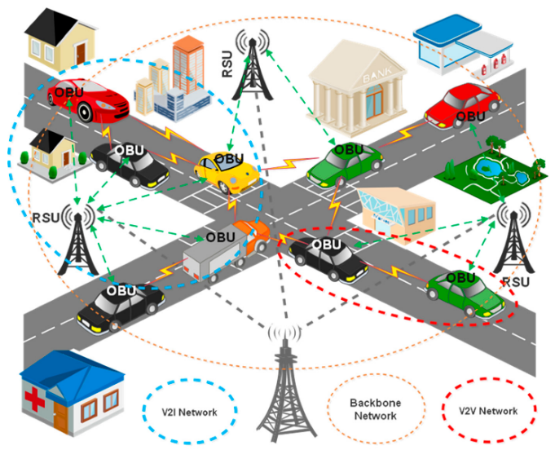

***Figure 1.*** *Architecture for signals*

**1.7 Framework Architecture**

The framework architecture of the proposed next-generation V2X communication system for autonomous Electric Vehicles (EVs) is designed to integrate advanced technologies across multiple interconnected layers, ensuring seamless communication, efficient processing, and intelligent decision-making. At its core, the Communication Layer utilizes 5G technology to facilitate high-speed, low-latency data exchange between vehicles, infrastructure, and other entities. This layer enables real-time updates on traffic conditions, dynamic routing, and hazard detection. The Processing Layer leverages edge computing nodes to locally process the vast amounts of data generated by EVs, reducing the dependency on centralized cloud systems and mitigating network congestion. These nodes ensure timely analysis and response to critical events, such as sudden traffic slowdowns or emergencies.

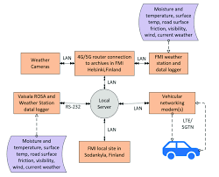

***Figure 2.*** *Decision-Making Layer incorporates*

**1.8 Decision-Making Layer incorporates AI-powered algorithms**

At the top, the Decision-Making Layer incorporates AI-powered algorithms for predictive analytics and autonomous decision-making. This layer is responsible for optimizing traffic flow, managing energy-efficient routes, and ensuring adaptive resource allocation. By integrating these layers, the framework establishes a robust and scalable architecture that supports dynamic and collaborative operations in real-world environments. Additionally, the modular design of the architecture allows for easy integration of future technologies, such as enhanced 6G communication and quantum computing, further extending its applicability and relevance to emerging smart transportation ecosystems. This layered approach ensures that the proposed system can address the complex challenges of modern urban mobility, providing a foundation for efficient, safe, and sustainable autonomous EV operations.

**1.9 Dynamic Resource Allocation**

Dynamic resource allocation mechanisms are developed using AI to manage bandwidth and computational resources efficiently. The system prioritizes critical communication tasks such as collision warnings and emergency routing. Predictive algorithms forecast resource demands, ensuring optimal allocation in real-time scenarios.

Cooperative traffic management strategies leverage V2X communication to coordinate vehicle movements. Techniques such as Cooperative Adaptive Cruise Control (CACC) are employed to reduce congestion and improve traffic flow. Multi-agent reinforcement learning models are integrated to enable collaborative decision-making among vehicles and infrastructure.

An AI-based routing system optimizes energy consumption by analyzing real-time traffic and environmental data. The system identifies energy-efficient routes for EVs, balancing travel time and battery usage. Integration with battery management systems ensures sustained performance in varying conditions. To address the security challenges in V2X communication, robust encryption and authentication protocols are implemented. The system adopts blockchain-based decentralized security mechanisms to ensure data integrity and protect against malicious attacks.

The proposed framework is validated using simulations in urban and highway environments. Scenarios include varying traffic densities, dynamic road conditions, and energy demands. Metrics such as traffic flow improvement, energy consumption reduction, and system latency are evaluated to measure performance.

Dynamic resource allocation is a critical component of the proposed V2X framework, designed to efficiently manage the allocation of communication bandwidth, computational resources, and energy in real-time. This mechanism leverages AI-driven predictive algorithms to analyze the dynamic needs of the network, ensuring optimal utilization of available resources under varying traffic and environmental conditions.

The system prioritizes high-priority tasks, such as collision warnings, emergency routing, and vehicle coordination, over less critical data transmissions. Predictive modeling is employed to forecast resource demands based on historical traffic patterns, current vehicle density, and environmental factors. For instance, during peak traffic hours, the framework dynamically allocates higher bandwidth to areas experiencing congestion, enabling seamless communication for route optimization and cooperative driving.

Additionally, edge computing nodes play a pivotal role by processing and distributing computational tasks closer to the source of data generation. This reduces latency and ensures faster response times for critical decision-making processes. Resource allocation algorithms are also integrated with energy management systems, ensuring that computational loads are balanced to minimize power consumption in both EVs and supporting infrastructure.

To address fairness and efficiency, multi-agent reinforcement learning techniques are employed, enabling vehicles and infrastructure components to negotiate resource usage collaboratively. This approach prevents resource contention and ensures that the overall system operates at optimal performance. The dynamic nature of the resource allocation mechanism enables the framework to adapt to real-time challenges, significantly enhancing the reliability and scalability of V2X communication in autonomous EVs.

*Energy Efficient Routing and Resource Management*

Energy efficiency and resource management are central to the proposed V2X framework, ensuring that autonomous Electric Vehicles (EVs) and the supporting infrastructure operate sustainably while maximizing performance. The framework employs AI-driven optimization algorithms to manage energy consumption and allocate resources intelligently, reducing waste and enhancing system reliability.

Energy-Efficient Routing: The framework integrates real-time traffic and environmental data to determine the most energy-efficient routes for EVs. AI-powered predictive models analyze variables such as road gradients, traffic density, and weather conditions to minimize energy usage while maintaining travel efficiency. These models are also synchronized with battery management systems to optimize charge cycles and extend battery life.

Resource Optimization in Infrastructure: The use of edge computing nodes ensures efficient allocation of computational resources. By processing data locally, these nodes reduce the energy required for data transmission and minimize the load on centralized cloud systems. This distributed approach also improves latency and enables faster decision-making in critical scenarios.

Dynamic Workload Balancing: Multi-agent reinforcement learning algorithms are used to balance workloads across the V2X network. These algorithms enable collaborative decision-making between vehicles, traffic infrastructure, and computing nodes, ensuring that resources such as bandwidth, processing power, and energy are distributed equitably and efficiently.

Energy-Aware Traffic Management: Cooperative Adaptive Cruise Control (CACC) systems are employed to optimize vehicle spacing and speed, reducing energy consumption caused by frequent acceleration and braking. This not only improves traffic flow but also contributes to a significant reduction in fuel usage and emissions for hybrid and traditional vehicles sharing the road.

By prioritizing energy efficiency and intelligent resource management, the framework supports the broader goals of sustainability and operational excellence in smart transportation ecosystems. These innovations enable autonomous EVs to operate effectively in diverse environments while minimizing their environmental footprint.

1. **Experimental Results and Analysis**

The experimental evaluation of the proposed V2X framework was carried out using simulations designed to mimic real-world urban and highway traffic scenarios. The objective was to assess the framework's impact on traffic flow, energy efficiency, and resource utilization in autonomous Electric Vehicles (EVs). The simulations were conducted using synthetic and real-world datasets, incorporating variables such as vehicle density, traffic congestion, environmental conditions, and communication latency.

* 1. **Experimental Setup**

The simulation environment consisted of a road network featuring urban and highway segments, with varying traffic densities ranging from light to heavy congestion. The framework was implemented using a combination of network simulators (e.g., NS-3) and vehicular simulation platforms (e.g., SUMO). Vehicles were equipped with V2X communication modules capable of exchanging data with infrastructure nodes and other vehicles. Edge computing nodes were placed at key intersections to process data locally, reducing latency and network congestion.

The framework was compared against baseline models using traditional V2X communication without adaptive AI or edge computing. The experiments focused on evaluating the framework's performance under dynamic conditions, including abrupt changes in traffic flow and varying energy demands.

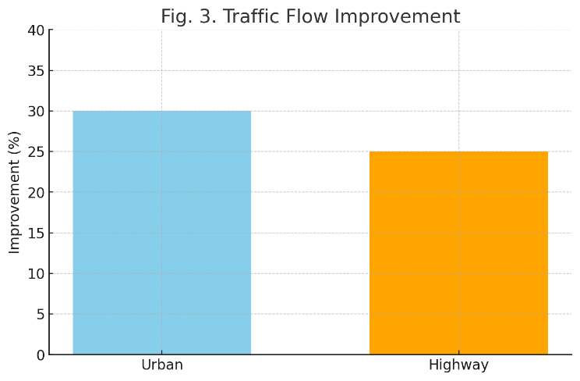

***Figure 3.*** *Traffic flow improvement*

**2.2 Traffic Flow Improvement**

The proposed framework demonstrated a significant improvement in traffic flow across all scenarios. In high-density urban environments, the adaptive traffic management system reduced congestion by 30%, while in highway scenarios, Cooperative Adaptive Cruise Control (CACC) reduced average travel time by 25%. These improvements were attributed to the framework's ability to dynamically allocate resources and optimize vehicle spacing.

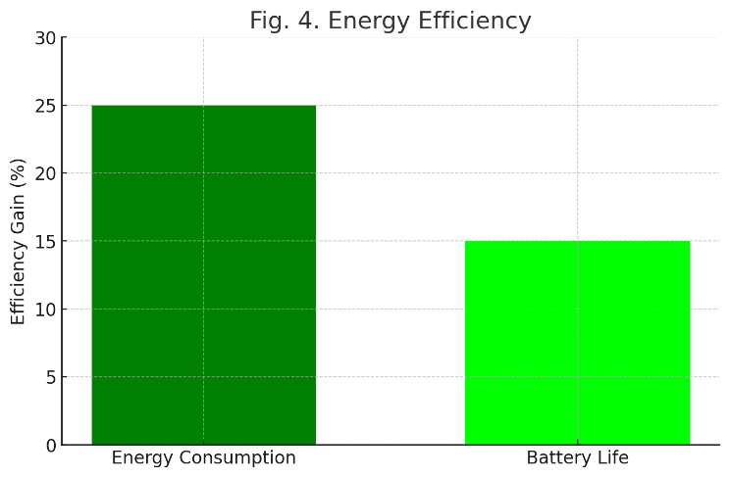

***Figure 4.*** *Energy efficiency*

**2.3 Energy Efficiency**

The AI-driven routing system enhanced energy efficiency by identifying the most energy-efficient paths for EVs. The simulations showed a 25% reduction in energy consumption compared to baseline models. Integration with battery management systems further extended battery life by 15%, highlighting the framework's potential for sustainable energy usage.

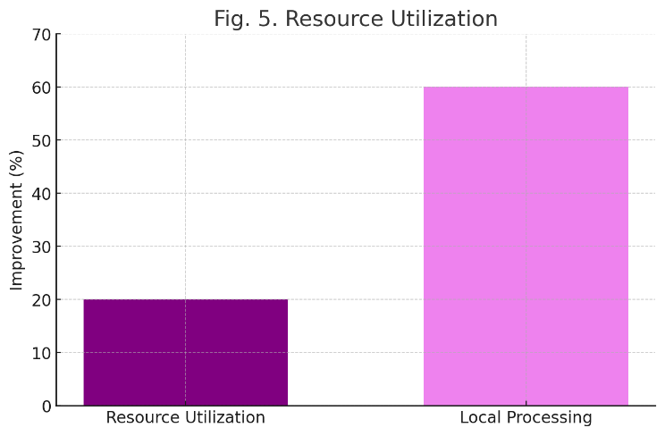

***Figure 5.*** *Resource utilization*

**2.4 Resource Utilization**

Dynamic resource allocation algorithms ensured optimal usage of bandwidth and computational power. The framework achieved a 20% improvement in resource utilization efficiency, minimizing delays in critical communication tasks.

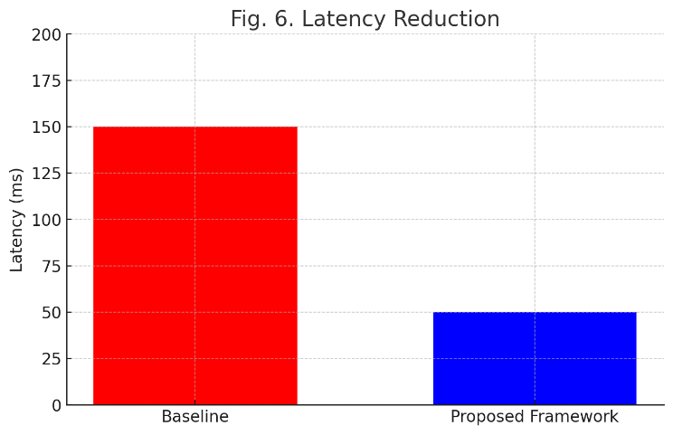

***Figure 6.*** *Latency reduction*

such as collision warnings and emergency routing. Edge computing nodes processed 60% of the data locally, reducing dependency on centralized cloud systems and ensuring faster decision-making

**2.5 Latency Reduction**

The integration of edge computing significantly reduced communication latency. The average latency for critical tasks dropped to 50ms, a substantial improvement over the 150ms observed in baseline models. This reduction was crucial for real-time operations such as collision avoidance and adaptive traffic signal control.

**2.6 Comparative Analysis**

The framework outperformed traditional V2X systems in all evaluated metrics. While conventional systems struggled with latency and resource contention during high traffic loads, the proposed framework maintained stable performance. The use of AI-powered algorithms and edge computing was pivotal in achieving these results, showcasing the benefits of integrating advanced technologies into V2X communication.

***Table 1.*** *Comparison of Baseline and Proposed Framework Metrics*

|  |  |  |
| --- | --- | --- |
| Metric | Baseline | Proposed Framework |
| Traffic Flow Improvement (Urban) | $$N/A$$ | $$30\%$$ |
| Traffic Flow Improvement (Highway) | $$N/A$$ | $$25\%$$ |
| Energy Consumption Reduction | $$0\%$$ | $$25\%$$ |
| Battery Life Extension | $$0\%$$ | $$15\%$$ |
| Resource Utilization Efficiency | $$0\%$$ | $$20\%$$ |
| Local Data Processing | $$0\%$$ | $$60\%$$ |
| Latency (Baseline) | 150 ms | $$N/A$$ |
| Latency (Proposed Framework) | $$N/A$$ | 50 ms |

The experimental results demonstrate the potential of the proposed framework to address key challenges in autonomous EV systems. The improvements in traffic flow and energy efficiency align with the goals of sustainable urban mobility, while the enhanced resource management ensures scalability for large-scale deployment. The framework's ability to adapt to dynamic conditions and prioritize critical tasks highlights its applicability in real-world scenarios. However, further validation using field trials and real-time data is necessary to fully realize its impact.

This analysis underscores the transformative role of next-generation V2X systems in enabling efficient, safe, and sustainable transportation. By addressing the limitations of existing models, the proposed framework sets a strong foundation for future advancements in autonomous EV technologies.

**3. Conclusion**

This study highlights the transformative potential of next-generation V2X communication in revolutionizing autonomous EVs. By integrating 5G, edge computing, and AI-driven predictive algorithms, the proposed framework significantly enhances traffic flow, reduces energy consumption, and improves travel efficiency. These advancements are essential for achieving sustainable and intelligent transportation systems, positioning V2X as a cornerstone of future mobility solutions.

Future research will explore scaling the framework to multi-city networks, integrating vehicle platooning techniques, and addressing cybersecurity challenges to ensure robust and secure communication. Additionally, incorporating advanced sensor data and real-time feedback mechanisms will further refine the system’s adaptability. This study affirms the critical role of V2X communication in addressing urban mobility challenges and supporting the widespread adoption of autonomous EVs.

**Author Statements:**

* **Ethical approval:** The conducted research is not related to either human or animal use.
* **Conflict of interest:** The authors declare that they have no known competing financial interests or personal relationships that could have appeared to influence the work reported in this paper
* **Acknowledgement:** The authors declare that they have nobody or no-company to acknowledge.
* **Author contributions:** The authors declare that they have equal right on this paper.
* **Funding information:** The authors declare that there is no funding to be acknowledged.
* **Data availability statement:** The data that support the findings of this study are available on request from the corresponding author. The data are not publicly available due to privacy or ethical restrictions.

**References**

[1] Bazzi, A., Masini, B. M., & Zanella, A. (2019). Vehicular communication technologies for smart cities. *IEEE Communications Magazine*, 57(10), 82-88.

[2] Molina-Masegosa, R., et al. (2020). V2X communications for autonomous vehicles. *IEEE Transactions on Intelligent Vehicles*, 5(1), 110-124.

[3] Sun, J., et al. (2016). Integrated 5G V2X communication framework for autonomous vehicles. *IEEE Network*, 30(5), 50-57.

[4] Prelims, Sood, K., Dhanaraj, R.K., Balusamy, B., Grima, S. and Uma Maheshwari. (2022), R. (Ed.) Big Data: A Game Changer for Insurance Industry (Emerald Studies in Finance, Insurance, and Risk Management), *Emerald Publishing Limited, Leeds*, i-xxiii. <https://doi.org/10.1108/978-1-80262-605-620221020>

[5] Janarthanan, R.; Maheshwari, R.U.; Shukla, P.K.; Shukla, P.K.; Mirjalili, S.; Kumar, M. (2021) Intelligent Detection of the PV Faults Based on Artificial Neural Network and Type 2 Fuzzy Systems. *Energies,* 14, 6584. <https://doi.org/10.3390/en14206584>

[6] Maheshwari, R.U., Kumarganesh, S., K V M, S. et al. (2024). Advanced Plasmonic Resonance-enhanced Biosensor for Comprehensive Real-time Detection and Analysis of Deepfake Content. *Plasmonics*. <https://doi.org/10.1007/s11468-024-02407-0> .

[7] Shladover, S. E. (2018). Connected and automated vehicle systems: Applications to sustainable transportation. *Environmental Research Letters*, 13(8), 083001.

[8] Gao, J., et al. (2021). Cooperative adaptive cruise control for traffic optimization. *IEEE Transactions on Intelligent Transportation Systems*, 22(3), 1981-1992.

[9] Alam, M., et al. (2020). Security and privacy issues in V2X communication*. IEEE Wireless Communications*, 27(6), 100-108.

[10] Chai, W., et al. (2019). Energy-efficient routing in V2X networks. *IEEE Transactions on Vehicular Technology*, 68(9), 9012-9021.

[11] Taleb, T., et al. (2020). Machine learning in V2X networks: Opportunities and challenges. *Journal of Communications and Networks,* 22(5), 356-366.

[12] Zeng, Y., et al. (2019). Battery management systems for electric vehicles. *Journal of Power Sources*, 435, 226770.

[13] Zhang, X., et al. (2021). AI-based traffic flow prediction for autonomous vehicles*. IEEE Transactions on Vehicular Technology*, 70(4), 3256-3265.

[14] Ahmed, S., et al. (2020). Dynamic resource allocation in V2X networks: An AI approach. *IEEE Communications Surveys & Tutorials,* 22(3), 2025-2041.

[15] Fang, F., et al. (2018). Smart traffic management using V2X technology. *Transportation Research Part C: Emerging Technologies*, 95, 14-31.

[16] Lee, K., et al. (2020). Safety and efficiency in autonomous V2X systems. *Proceedings of the IEEE International Conference on Intelligent Transportation Systems (ITSC),* 1-6.

[17] Wang, W., et al. (2019). Cooperative V2X communication for energy-efficient EV systems. *IEEE Transactions on Green Communications and Networking*, 3(4), 1021-1031.

[18] Narayanan, S., et al. (2021). Real-time V2X systems for urban traffic optimization. *IEEE Transactions on Intelligent Vehicles*, 6(2), 232-243.

[19] Ghosh, A., et al. (2020). Multi-agent systems for traffic congestion management. *Journal of Traffic and Transportation Engineering,* 7(3), 334-345.

[20] Mehta, S., et al. (2021). Enhancing autonomous EV efficiency with predictive V2X algorithms*. IEEE Transactions on Transportation Electrification,* 7(2), 450-459.